Experiment - 1

Aim : Consider following databases and draw ER diagram and convert entities
and relationships to relation table for a given scenario:
COLLEGE DATABASE:
STUDENT (USN, SName, Address, Phone, Gender)
SEMSEC (SSID, Sem, Sec)
CLASS (USN, SSID)
SUBJECT (Subcode, Title, Sem, Credits)
IAMARKS (USN, Subcode, SSID, Test1, Test2, Test3, FinalIA)

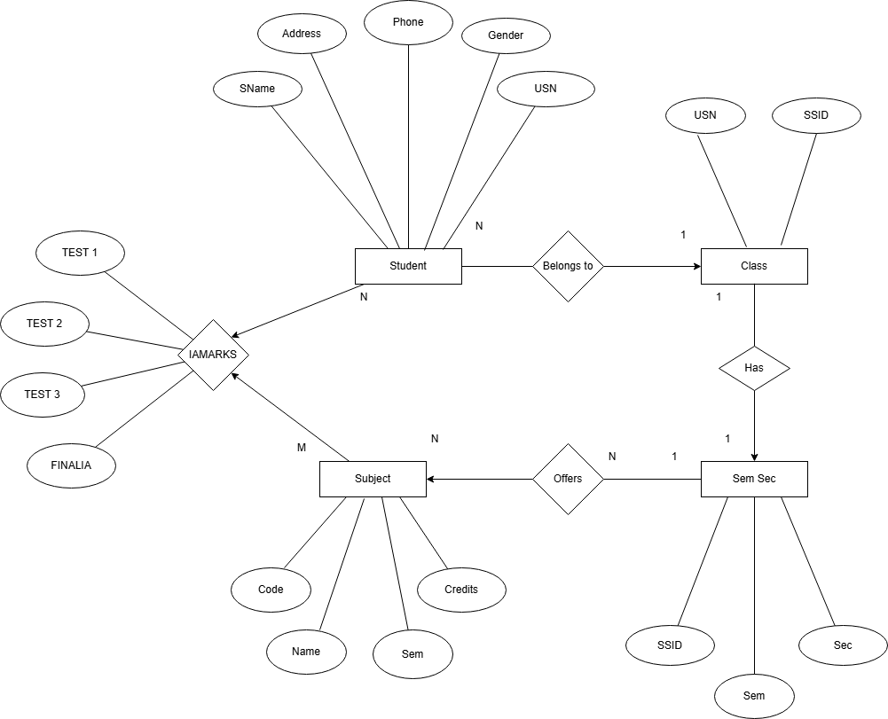
ER diagram for a College Database to represent how different academic data is organized and related.
STUDENT entity stores student details like USN, name, address, phone, and gender.
SEMSEC entity represents semester and section information using SSID.
CLASS is a relationship that connects STUDENT and SEMSEC, showing which student belongs to which semester and section.
SUBJECT entity stores subject details such as subject code, title, semester, and credits.
IAMARKS entity records internal assessment marks of students for each subject, including Test1, Test2, Test3, and Final IA marks. It connects STUDENT, SUBJECT, and SEMSEC using keys like USN, Subcode, and SSID.

Experiment - 2

Aim : Consider following databases and draw ER diagram and convert entities
and relationships to relation table for a given scenario:
COMPANY DATABASE:
EMPLOYEE (SSN, Name, Address, Sex, Salary, SuperSSN, DNo)
DEPARTMENT (DNo, DName, MgrSSN, MgrStartDate)
DLOCATION (DNo,DLoc)
PROJECT (PNo, PName, PLocation, DNo)
WORKS_ON (SSN, PNo, Hours)

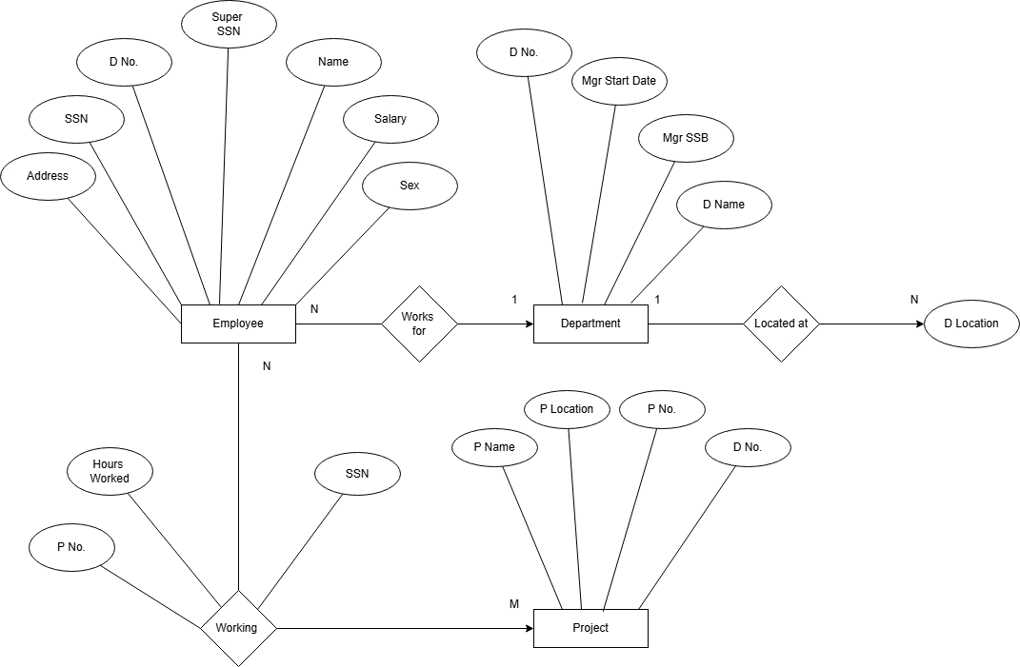
ER diagram for a Company Database to represent employees, departments, projects, and their relationships.
EMPLOYEE entity stores employee details such as SSN, name, address, sex, salary, supervisor SSN, and department number.
DEPARTMENT entity contains department information like department number, department name, manager SSN, and manager start date.
DLOCATION entity represents the different locations of each department.
PROJECT entity stores project details such as project number, project name, project location, and department number.
WORKS_ON is a relationship between EMPLOYEE and PROJECT that records how many hours an employee works on a project.
The ER diagram also shows relationships like employee supervision, employees working for departments, and departments controlling projects.

Experiment - 3

Aim : Database Schema for a customer-sale scenario:
Customer(Cust id : integer, cust_name: string) Item(item_id: integer, item_name: string, price: integer)
Sale(bill_no:integer,bill_data:date,cust_id: integer, item_id: integer, qty_sold: integer) For the above schema, perform the following:
SOLUTION :
- Create tables with the appropriate integrity constant.
CREATE DATABASE RetailManagementDB;
USE RetailManagementDB;
CREATE TABLE Customer (
cust_id INT PRIMARY KEY,
cust_name VARCHAR(100) NOT NULL
);
CREATE TABLE Product (
product_id INT PRIMARY KEY,
product_name VARCHAR(100) NOT NULL,
price INT NOT NULL CHECK (price > 0)
);
CREATE TABLE Sales (
bill_no INT,
bill_date DATE NOT NULL,
cust_id INT NOT NULL,
product_id INT NOT NULL,
quantity INT NOT NULL CHECK (quantity > 0),
PRIMARY KEY (bill_no, product_id),
FOREIGN KEY (cust_id) REFERENCES Customer(cust_id),
FOREIGN KEY (product_id) REFERENCES Product(product_id)
);

b)Insert 10 records in each table.
INSERT INTO Customer VALUES
(1,'Rohan'),(2,'Karan'),(3,'Sahil'),(4,'Deepak'),(5,'Arjun'),
(6,'Manish'),(7,'Tarun'),(8,'Varun'),(9,'Nikhil'),(10,'Harsh');
INSERT INTO Product VALUES
(201,'Smartphone',20000),
(202,'Bluetooth Speaker',2500),
(203,'Smart Watch',5000),
(204,'Gaming Mouse',1500),
(205,'External HDD',4500),
(206,'LED TV',35000),
(207,'Router',1800),
(208,'Power Bank',1200),
(209,'Laptop Stand',900),
(210,'Webcam',3000);
INSERT INTO Sales VALUES
(5001,CURDATE(),1,201,1),
(5002,CURDATE(),2,202,2),
(5003,CURDATE(),3,203,1),
(5004,CURDATE(),4,204,3),
(5005,CURDATE(),5,205,1),
(5006,DATE_SUB(CURDATE(),INTERVAL 1 DAY),6,206,1),
(5007,DATE_SUB(CURDATE(),INTERVAL 2 DAY),7,207,2),
(5008,DATE_SUB(CURDATE(),INTERVAL 3 DAY),8,208,2),
(5009,DATE_SUB(CURDATE(),INTERVAL 4 DAY),9,209,4),
(5010,DATE_SUB(CURDATE(),INTERVAL 5 DAY),10,210,1);
(c) List bills for current date with customer names and item numbers
SELECT s.bill_no, s.bill_date, c.cust_name, s.product_id
FROM Sales s
JOIN Customer c ON s.cust_id = c.cust_id
WHERE s.bill_date = CURDATE();
(d) List total Bill details with qty, price, and final amount.
SELECT s.bill_no, c.cust_name, p.product_name, s.quantity, p.price,
(s.quantity * p.price) AS total_amount
FROM Sales s
JOIN Customer c ON s.cust_id = c.cust_id
JOIN Product p ON s.product_id = p.product_id;
(e) List details of customers who bought products with price > 2000.
SELECT DISTINCT c.*
FROM Customer c
JOIN Sales s ON c.cust_id = s.cust_id
JOIN Product p ON s.product_id = p.product_id
WHERE p.price > 2000;
(f) Count of products bought by each customer
SELECT c.cust_id, c.cust_name, COUNT(s.product_id) AS products_bought
FROM Customer c
LEFT JOIN Sales s ON c.cust_id = s.cust_id
GROUP BY c.cust_id, c.cust_name;
(g) Products bought by customer with cust_id 5.
SELECT p.product_name, p.price, s.quantity
FROM Sales s
JOIN Product p ON s.product_id = p.product_id
WHERE s.cust_id = 5;
(i) Create view for bill details
CREATE VIEW Bill_Summary AS
SELECT s.bill_no, s.bill_date, s.cust_id, s.product_id,
p.price, s.quantity, (s.quantity*p.price) AS amount
FROM Sales s
JOIN Product p ON s.product_id = p.product_id;
(j) Create view for weekly daily sales
CREATE VIEW Weekly_Sales_Report AS
SELECT s.bill_date,
SUM(s.quantity * p.price) AS total_sales
FROM Sales s
JOIN Product p ON s.product_id = p.product_id
WHERE s.bill_date >= DATE_SUB(CURDATE(), INTERVAL 7 DAY)
GROUP BY s.bill_date;
Output: